

INFORMATION
- Reference: | WIS-SecurityServiceStudy-01
- Version: | 01.0
- Approved by: | Yannick Lizzi
- Date: | 2022/10/10

- Approval
Action | Name | Function | Date
Written by | Brahim HANDALA | Developer | 05/10/2022
Checked by | Yannick LIZZI | Head of Department | 05/10/2022
- Revision table
Version | Date | Update description
00.1 | 05/10/2022 | Creation – preliminary results
01.0 |  | First version

- TABLE OF CONTENTS
1 Introduction 4
2 Migrating OpenAM to Keycloak 5
2.1 OpenWIS using OpenAM 5
2.1.1 General considerations 5
2.1.2 Fedlet / Service Provider / OpenAM 5
2.1.3 Identity Provider 5
2.1.4 Circle of Trust 6
2.1.5 OpenWIS authentication steps 7
2.1.6 Authenticate request examples 8
2.2 Keycloak to secure OpenWIS 9
2.2.1 Environment OpenWIS settings 9
2.2.2 KeyCloak server settings 10
2.2.3 Back-end development code 13
2.3 Table of impacted components 15
3 Alternate solutions for authentication 17
3.1 LDAP only 17
3.1.1 Description 17
3.1.2 Architecture 17
3.1.3 Table of impacted components 18
3.2 Corporate Proxy 19
3.2.1 Description user-portal 19
3.2.2 Architecture user-portal 19
3.2.3 Table of impacted components 20
3.2.4 Description admin-portal 21
3.2.5 Architecture admin-portal 21
3.2.6 Table of impacted components 22
4 Conclusion 23

Introduction
OpenWIS relies on OpenAM for Single Sign-On authentication.

OpenAM is an open-source SSO solution that comes with a lot of functionalities, successor of OpenSSO. This solution was selected in OpenWIS several years ago because it was compliant with SAML v2 protocol and allowed to address the multiple use cases envisaged at the origin of the development (including federation of identity providers).

Deploying and configuring OpenSSO / OpenAM has always been a challenge, and a serious constraint for install/setup automatization.
The OpenAM community is still active, but a large part of the solution still relies on old OpenSSO source code and technologies.
Moreover, the library dependencies are not always available on recent repositories, which causes compilation issues.

In the recent years, several new SSO solutions have arisen, coming with new technologies and new architecture.

The OpenWIS association has previously led a study, identifying Keycloak as a potential replacement for OpenAM.
The first chapter of this study gets into details of migrating from OpenAM to Keycloak and the impact on OpenWIS source code.
It also provides an attempt to assess the complexity of setting up Keycloak within OpenWIS by looking at the different modules, the classes that will be impacted and all the configurations necessary for the operation of authentication.

The second chapter explores alternate solutions for authenticating a User in OpenWIS:
    - Using LDAP only
    - Using Corporate proxy

Migrating OpenAM to Keycloak

OpenWIS using OpenAM

General considerations
This section will describe some concepts and components of OpenAM used in OpenWIS and that will be impacted by a migration to Keycloak.

OpenAM is used for:
- User Authentication
- Single Sign-On
- Federation
- Managing user session: login / logout / check if the session is valid

It relies on OpenDJ, which is an LDAP solution as a repository to store Users and Groups.

Fedlet / Service Provider / OpenAM
The Fedlet is a streamlined Service Provider implementation of SAMLv2 single sign-on (SSO) protocols.
It is designed to be used by Service Providers when the primary goals are to achieve single sign-on with an Identity Provider while also retrieving some user attributes from the Identity Provider.
A Fedlet instance is included on each portal.
Thanks to the Fedlet each portal becomes a Service Provider.

In OpenWIS, the Fedlet allows to retrieve user attributes during the authentication phase (such as Name, Username, Surname, Contact email…)

Identity Provider
An Identity Provider (abbreviated “IdP”) is a service hosted by an organization which publishes electronic information for users that have a firm relationship with the organization.
An “Identity Federation” is a structured co-operation between different Identity Providers. In a federation, IdPs will multilaterally exchange electronic identity information, such as names and other personal data.
OpenAM is one example of an Identity Federation.
OpenAM is used to configure Identity Federation: create Circle of Trust, register Remote Identity Provider or Service Provider, and create Hosted Identity Provider or Service Provider…
OpenAM uses SAML protocol to define SSO Federation.

Circle of Trust
A Circle of Trust (abbreviated CoT) contains one or several Identity Provider and Service Providers allowed to perform federation between them.

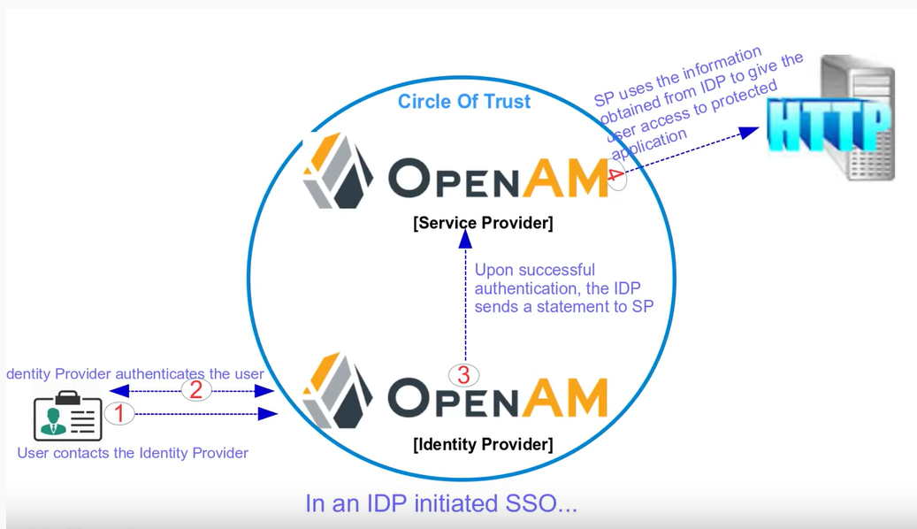

OpenWIS authentication steps
The following figure illustrates the authentication process implemented in OpenWIS.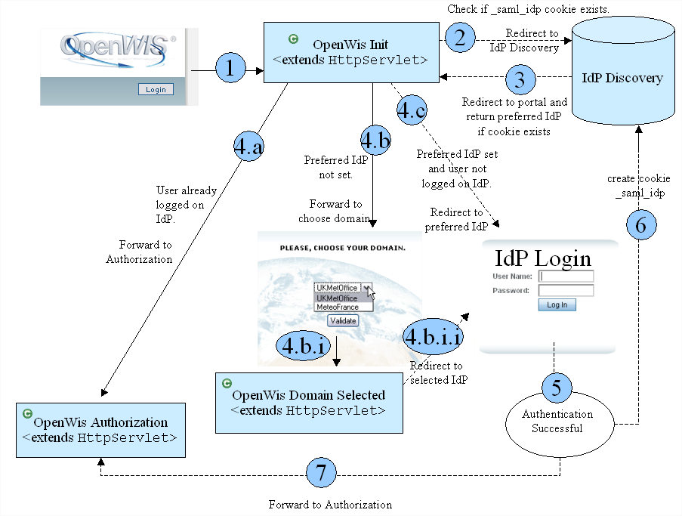

- The user clicks on Login button.
- OpenWIS Init servlet redirects to IdP Discovery if _saml_idp cookie exists.
- IdP Discovery redirects to portal and return the preferred IdP if the cookie exists.
- Three possibilities can occur:
  - User is already connected on the Centre; the authorisation phase can begin.
  - User has never chosen his preferred IdP. Choose your domain page is displayed
    - User validates his choice.
    - OpenWISDomainSelected class redirects to IdP login previously selected.
  - User has already chosen his preferred IdP, and he isn’t connected on the Centre. The user is redirected to his preferred IdP for login.
- Authentication is successful
- IdP Discovery creates _saml_idp cookie.
- The Authorisation can begin.

The system only logs the user login and no other personal information.

Below are listed the requested classes to perform an authentication:
- OpenWisInit
- SAML2MetaManager: get SP MetaAliases
- SAML2Utils: gets preferred identity providerIDP
- OpenWISMetadataPortalConfig: gets identity provider IP (IDP)
- SAML2Utils: connect to idpDiscobvery
- SPSSOFederate: to initiateAuthnRequest
- SPSSOFederate: gets Service provider IP
- SPSSOFederate: post request

Authenticate request examples
The below image shows of typical request sent to OpenAM.
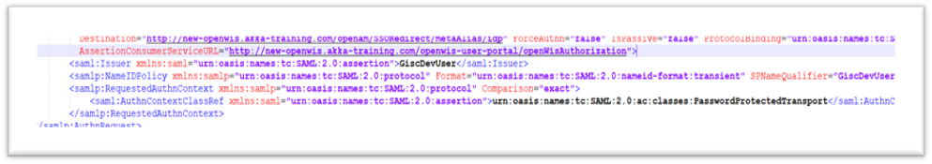
The following parameters are used by request.
- forceAuthn:(false/true)
- isPassive:(false/true)
- requestId:s2c9eb04b153e2274531e257c873c82803dd99999
- protocolBinding:urn:oasis:names:tc:SAML:2.0:bindings:HTTP-POST
- assertionConsumerServiceURL:http://openwis.akka-training.com/openwis-user-portal/openWisAuthorization
- destinationURI:http://openwis.akka-training.com/openam/SSORedirect/metaAlias/idp

Keycloak to secure OpenWIS
The Keycloak identity and access management tool should be installed
- Installing Keycloak
- Create client
- Create group
- Create users
- Create roles

Environment OpenWIS settings
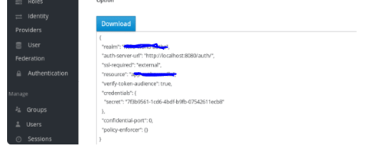
- Copy keycloak json into openwis WEB-INF

- Define security constraint
In web.xml: defines security constraint for to authentication and authorization setup
Example:
<security-constraint>
<web-resource-collection>
<web-resource-name>openwis</web-resource-name>
<url-pattern>/OpenWisInit/*</url-pattern>
</web-resource-collection>
<auth-constraint>
<role-name>user</role-name>
</auth-constraint>
</security-constraint>

- Install Keycloak adapter:
Install in tomcat Keycloak adapter" copy all adapter contain into /tomcat/lib.

- Copy context int META-INF /context.xml
The following property should be added into context.xml
<Context path="/openwis">
<Valve className="org.keycloak.adapters.tomcat.KeycloakAuthenticatorValve"/>
</Context
- Impacted class to be configured in web.xml
- OpenWisInit
- OpenWisAuthorization
- OpenWisLogin
- Logout
- OpenWisGetToken
- OpenWisRequestAccount

KeyCloak server settings
- Add Client: in this part we provide ClientID, protocol, root URL to the application as shown in bellow figure:
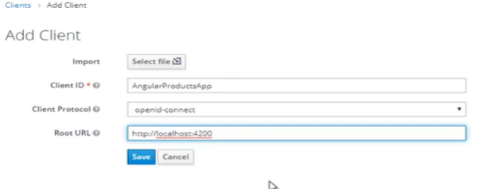

- Add roles (which are declared in openwis web.xml)
- Create groups

- Setup a user federation with keycloak
- Add user federation
- Setup connection to LDAP
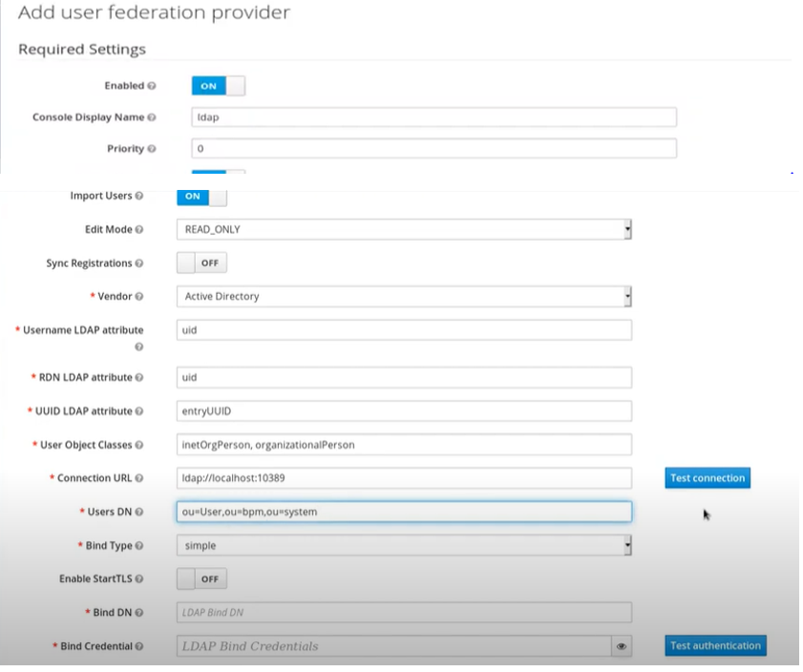
- Synchronize all users

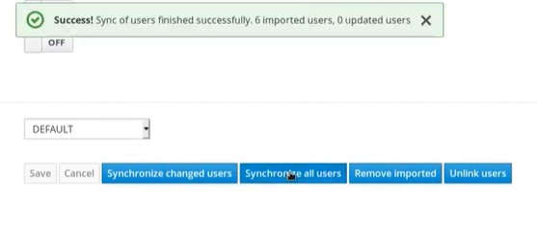

- Create user attributes

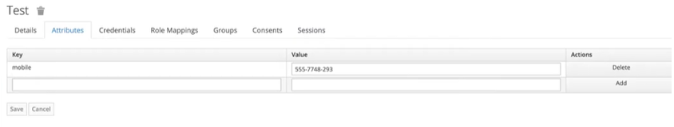

- Add Claim mapping
- Create a protocol Mapper (to map user attribute to token claim name)
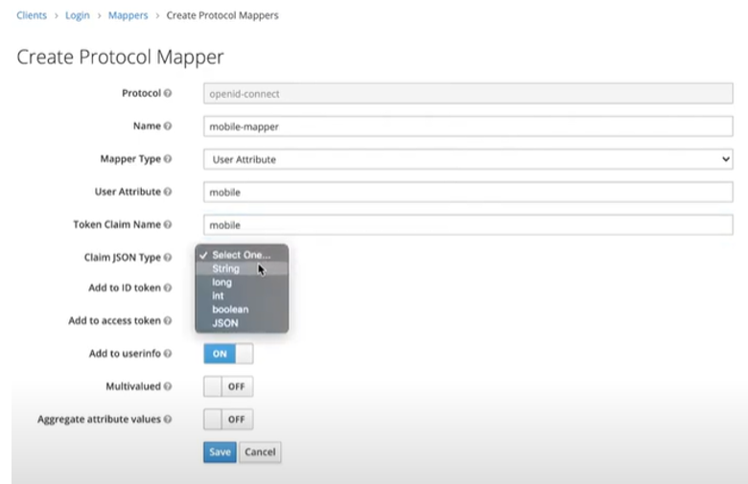

- The bellow figure shows the authentication to keycloak sequence diagram

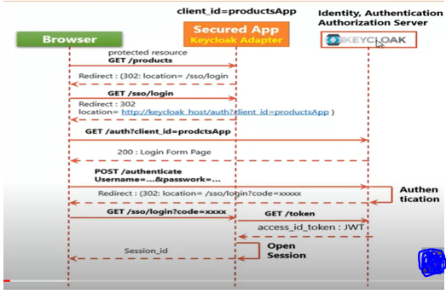

Back-end development code
The following classes are used
- KeycloakPrincipal: Get token after authentication y using Keycloak (fig:1)
- KeycloakSecurityContext: Verify if user is logged in keycloak by validating token in request (fig:2)
- AccessToken: get credentials (fig:1)

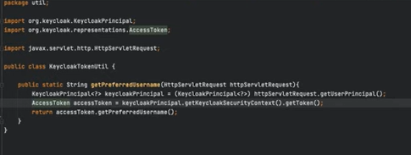

Fig:1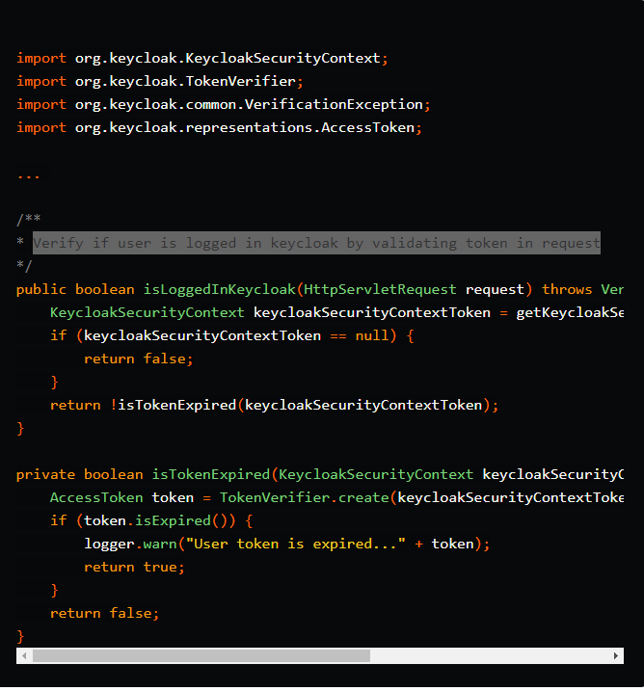
Fig:2

- Logout From Keycloak
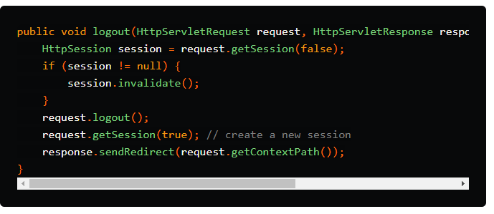

- Access claims
Retrieve user informationfrom Keycloak by using attributes the bellow figure show a code example
Example1:
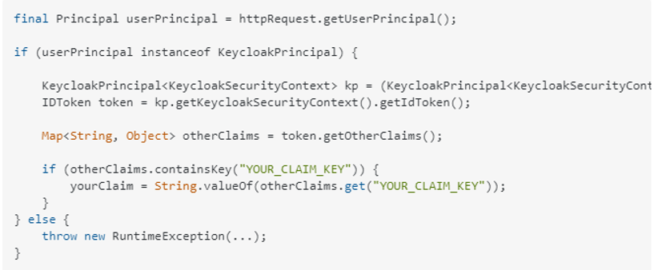
Example2:
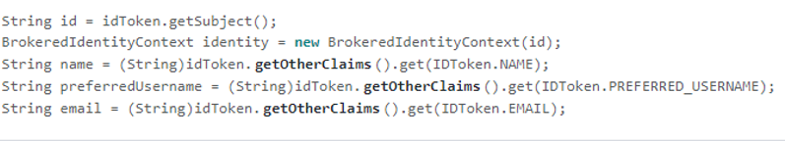

Table of impacted components
Component to modify | OpenAM | Keycloak | Complexity Level | Complexity Causes
OpenWisInit | Connect to IDP | Get credentials  Check if user logging |  | Using of new libraries may cause non compatibility with existing code + testes
OpenWisAuthorization | Retrieves and sets all user privileges | Retrieves and sets all users privileges |  | Risk of making a lot of changes in code +Testes
Web.xml | Configure URLs map to servlets | Modifying whole web.xml  Add security constraint and roles to URLs requiring authentication |  | Risk of making a lot of changes in code +testes
Logout | Logout from OpenAM | Logout from keycloak |  | Using of new libraries may cause non compatibility with existing code Development +testes
Keycloak |  | Configure Keycloak  - To redirect to portal  - Add roles (declared in web.xml)  - Add groups  - Add user federation provider |  | configure keycloak with LDAP and openwis +testing
Tomcat | Not requesting fedlet | Add tomcat_keycloak_adapter |  | No development or configuration needed
OpenWIS-portal pom.xml | Remove all OpenAM dependencies. The listed below jars will be removed  - openam: openam-idpdiscovery:jar  - openam: openam-federation-library:jar  - commons: forgerock-guice-core:jar  - openam: openam-xacml3-schema  - openam: openam-wsfederation-schema:jar  - openam: openam-liberty-schema  - openam: openam-shared:jar  - openam: openam-saml2-schema | Add Keycloak dependencies  (Risk of non-compatibility with other libs) |  | Development +tests of the application with a new dependencies
Documentation | Remove all documentation related to Openam | Add a new documentation related to Keycloak |  | Describe cofigurations and results tests
OpenWIS/Webapp | Remove saml2 folder (contain all JSP files that permit fedlet to communicate with Openam) |  |  | Developement+test+making a lot changes in code
OpenWISGetToken | Token is read from cookie | The token can be read directly with spGetToken.jsp |  | Development and tests of non regression

Alternate solutions for authentication

LDAP only

Description
By setting up this option we remove Openam authentication, The authentication will be done with by checking user information are stored in OpenDJ.
The user logs in by clicking Login from front public page, captcha will show up after validation, user will be redirected to front login page which will be created in portal for this purpose,
User enter credentials and passes to init-Openwis service to be sent to authentication-process that is located in security-service-module. This process verifies the authenticity of a user from OpenDJ.
When the login is success the portal authorization-service request user roles and user groups from openDJ by using security-service-module services and grant access to portal functionalities.
If the login fails, the redirection to login page will be done with response error message.

Architecture
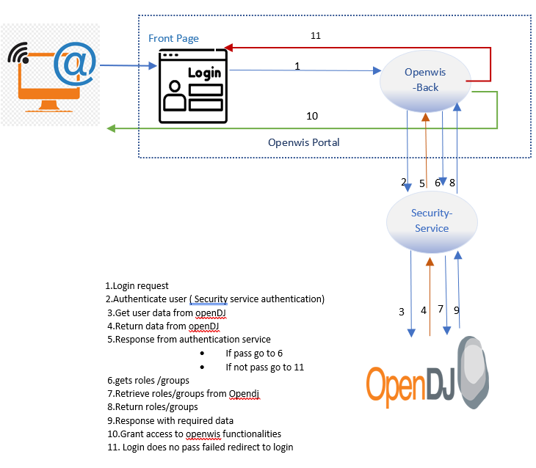

Table of impacted components
Component to modify | OpenAM | LDAP | Complexity Level | Complexity Causes
OpenWisInit | Connect to IDP | Connect and Authentication |  | Development and tests of non regression
OpenWisAuthorization | Retrieves and sets all user privileges | Retrieves and sets all users privileges |  | Development and tests of non regression
Logout | Logout from OpenAM | Log out from session |  | Development and tests of non regression
Login |  | Front Login page |  | Development and tests of non regression
OpenWIS-portal pom.xml | Remove all OpenAM dependencies The listed below jars will be removed  - openam: openam-idpdiscovery:jar  - openam: openam-federation-library:jar  - commons: forgerock-guice-core:jar  - openam: openam-xacml3-schema  - openam: openam-wsfederation-schema:jar  - openam: openam-liberty-schema  - openam: openam-shared:jar  - openam: openam-saml2-schema |  |  | Only removing dependencies no developement or configuration
Documentation | Remove all documentation related to Openam | Add a new documentation related to LDAP |  | Detailled and structured info
OpenWIS/Webapp | Remove saml2 folder (contain all Jsp files that permit fedlet to communicate with Openam) | Remove a code requesting saml2 folder files |  | Development and tests of non regression
OpenWISGetToken | Token is read from cookie | The token will be generated for openwis |  | Development and tests of non regression
OpenWisLoginCaptcha | Redirect to Openam login | Redirect to front login page |  | Development and tests of non regression
SecurityAutentication |  | Authenticate user (New service to create) |  | Development and tests of non regression

Corporate Proxy

Description user-portal
By choosing this option, Openam will be removed OpenDJ will be kept to retrieve all necessary user data. The corporate proxy will be in charge of user authentication using authentication service. In this case.
For user portal we need to have two URLs (one public-URL and other connect-URL) the proxy configuration will configure connect-URL to require authentication.
The user connects with user-portal using public URL by clicking on Login the connect-URL will be requested then the authentication will be asked from user.
If success the proxy will redirect to the portal page and in header the user data will be added.
Init-openwis service will get data from header and uses existing security-service-module services to get roles and
groups from OpenDJ.
If a user does not exist in OpenDJ he will be created with default rights using entered information (suggestion to
discuss about), the user data and privileges will be retrieved for authorizations from OpenDJ by using existing
security-service services. Tomcat configuration will be done to redirect two different URLs to same page.

Architecture user-portal 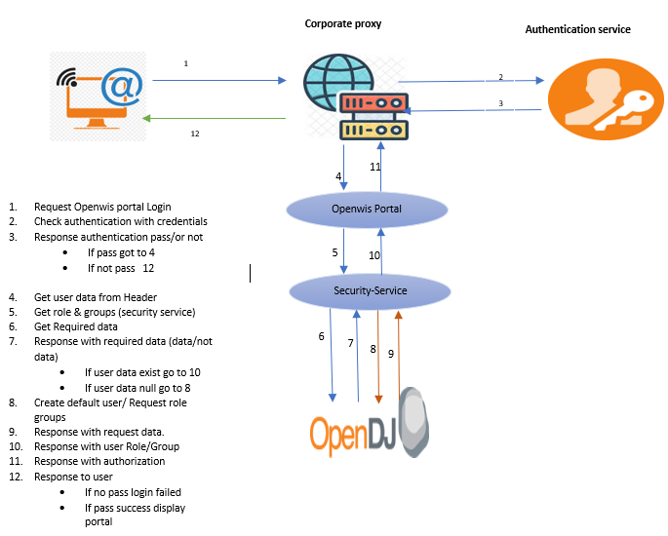

Table of impacted components

Component to modify | OpenAM | Corporate proxy | Complexity Level | Complexity Causes
OpenWisInit | Connect to IDP | Set the privileges and call openwis get token |  | Development and tests of non regression
Logout | Logout from Openam | Logout from openwis session |  | Development and tests of non regression
OpenWIS-portal pom.xml | Remove all OpenAM dependencies. The listed below jars will be removed  - openam: openam-idpdiscovery:jar  - openam: openam-federation-library:jar  - commons: forgerock-guice-core:jar  - openam: openam-xacml3-schema  - openam: openam-wsfederation-schema:jar  - openam: openam-liberty-schema  - openam: openam-shared:jar  - openam: openam-saml2-schema |  |  | Only removing dependencies no developement or configuration
Documentation | Remove all documentation related to Openam | Add a new documentation related to corporate proxy |  | Detailled and structured information
OpenWIS/Webapp | Remove saml2 folder (contain all JSP files that permit fedlet to communicate with Openam) | Remove a code requesting saml2 folder files |  | Development and tests of non regression
OpenWISGetToken | Token is read from cookie | The token will be read from cookie |  | Development and tests of non regression
OpenWisLoginCaptcha | Redirect to Openam | Remove captcha |  | Development and tests of non regression
Self-Registration | User self-Register it data to system | disabled (no possibility to self-register) |  | Development and tests

Description admin-portal
By choosing this option the Openam will be removed and OpenDJ is kept to get all user information. The corporate proxy will be in charge of user authentication. In this case. The connection to admin portal will require authentication it will be configured in corporate proxy.
The user connects to admin-portal the authentication will be asked from user If success the proxy would redirect to the portal page with user data added to header, if authentication failed the user will be asked again to authenticate
After success a service called do-filter-openwis checks if user is admin by using existing services of openwis-security-service to get user role from OpenDJ.
If user is an admin, then it gets groups and all admin information from OpenDJ by calling init-openwis service and using existing security-service services
Response will return to proxy with admi portal functionalities.
If user is not admin and a response with “no access right” will be returned.

Architecture admin-portal 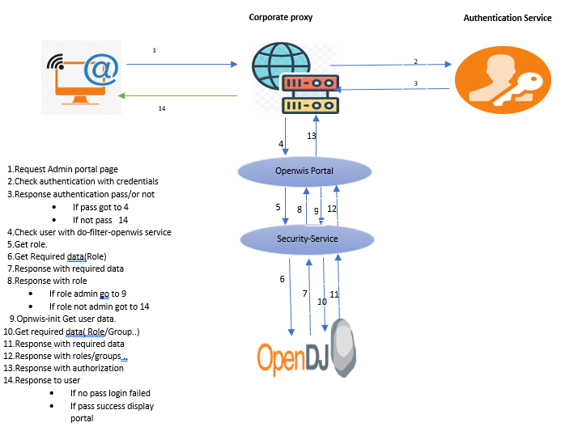

Table of impacted components
Component to modify | OpenAM | Corporate proxy | Complexity Level | Complexity Causes
OpenWisInit | Connect to IDP | Set the privileges and call openwis get token |  | Development and tests of non regression
Logout | Logout from Openam | Logout from openwis session |  | Development and tests of non regression
do_filter_openwis |  | Check if user is an admin |  | Development and tests of non regression
OpenWIS-portal pom.xml | Remove all OpenAM dependencies. The listed below jars will be removed  - openam: openam-idpdiscovery:jar  - openam: openam-federation-library:jar  - commons: forgerock-guice-core:jar  - openam: openam-xacml3-schema  - openam: openam-wsfederation-schema:jar  - openam: openam-liberty-schema  - openam: openam-shared:jar  - openam: openam-saml2-schema |  |  | Only removing dependencies no developement or configuration
Documentation | Remove all documentation related to Openam | Add a new documentation related to corporate proxy |  | Detailled and structured information
OpenWIS/Webapp | Remove saml2 folder (contain all jsp files that permit fedlet to communicate with Openam) | Remove a code requesting saml2 folder files |  | Development and tests of non regression
OpenWISGetToken | Token is read from cookie | The token will be read from cookie |  | Development and tests of non regression
OpenWisLoginCaptcha | Redirect to Openam | Remove captcha |  | Development and tests of non regression
Self-Registration | User self-Register it data to system | Disabled (no possibility to self-register) |  | Development and tests

Conclusion
This study gives an overview on OpenWIS impact related to component configuration and possible issues we could face by doing the migration. Also shows a different authentication mechanism to be set up.

